

**CLOUD COMPUTING REPORT**

**Aim:** To study and compare various cloud initiatives

-By Sanya Bhale

**Introduction**

The objective of this report is to throw light on the most used and important Technology “Cloud Computing” and various cloud initiatives such as Azure,Aws,Google Cloud etc.

*CLOUD COMPUTING*

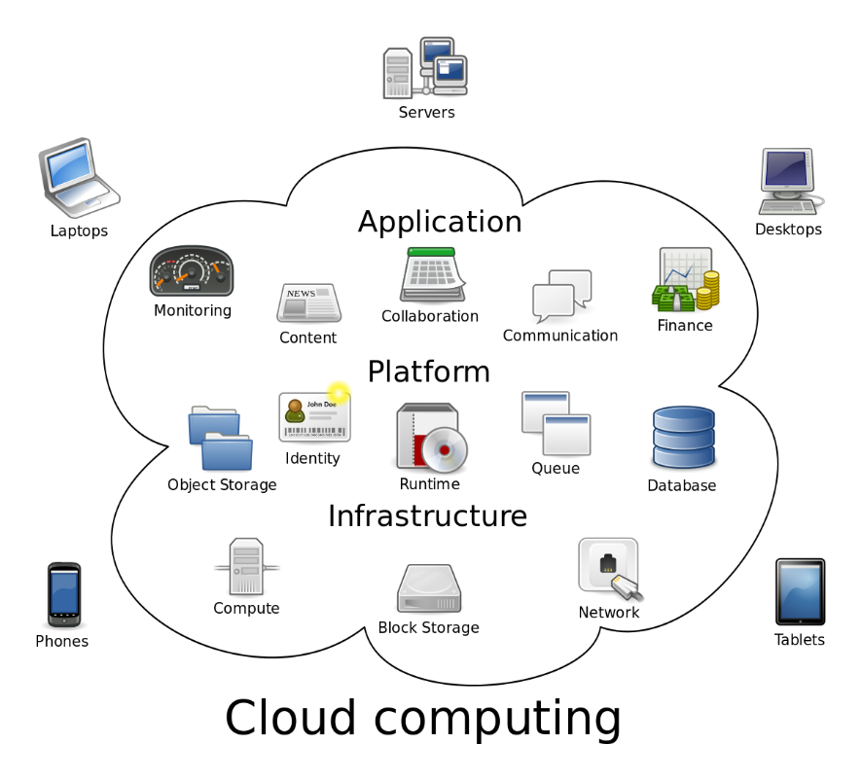

Cloud computing is an application-based software infrastructure that stores data on remote serves, which can be accessed through the internet.

Cloud Computing is the use of hardware and software to deliver a service over a network (typically the Internet). With cloud computing, users can access files and use applications from any device that can access the Internet.

An example of a Cloud Computing provider is Google's Gmail. Gmail users can access files and applications hosted by Google via the internet from any device.

*How it works?*

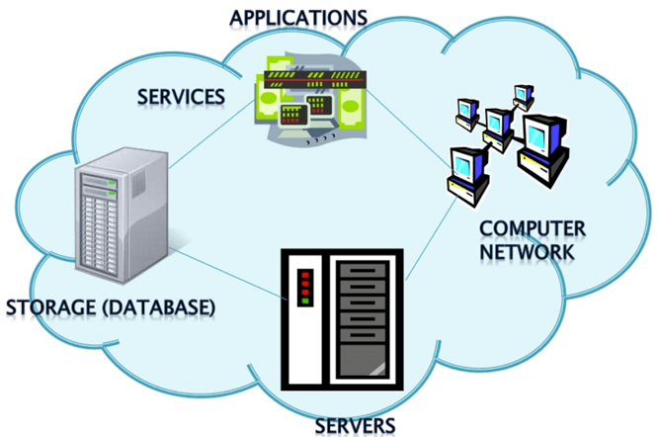

To understand how cloud computing works, it can be divided into front-end and backend.

The front end enables a user to access data stored in the cloud using an internet browser or a [cloud computing software](https://www.hcltech.com/services/cloud-computing). However, the primary component of cloud computing – responsible for securely storing data and information – is the backend. It comprises servers, computers, databases, and central servers.

The central server facilitates operations by following a set of rules known as protocols. It uses a software, middleware, to ensure seamless connectivity between devices/computers linked via cloud computing. Cloud computing service providers usually maintain multiple copies of the data to mitigate instances of security threats, data loss, data breach, etc.

Why Cloud Computing?

Basically, we need cloud computing because of the numerous individual and business problems that we encounter today. These problems range from acquiring and maintaining expensive hardware and software resources that we use in our daily operations to streamlining these resources in the most efficient manner for our benefit and the benefit of the society at large. In handling these challenges, cloud computing offers numerous benefits that have surpassed our expectations and delivered more than we had previously thought. These benefits are discussed below.

### Why is cloud computing important for business?

Pooled computing resources available through cloud computing have been proven to offer tremendous benefits to business organizations. Unraveling are these benefits broadly classified into three categories that include efficiency, flexibility, and strategic value.

* **Efficiency**

Efficiency in business operations is achieved in the following ways through the use of cloud computing:

* Accessibility; Cloud computing facilitates the access of applications and data from any location worldwide and from any device with an internet connection.
* Cost savings; Cloud computing offers businesses with scalable computing resources hence saving them on the cost of acquiring and maintaining them. These resources are paid for on a pay-as-you-go basis which means businesses pay only for the resources they use. This has proven to be much cheaper than acquiring the resources on their own.
* Security; Cloud providers especially those offering [private cloud services](http://www.ibm.com/cloud/learn/what-is-private-cloud), have strived to implement the best security standards and procedures in order to protect client’s data saved in the cloud.
* Disaster recovery; Cloud computing offers the most efficient means for small, medium and even large enterprises to backup and restore their data and applications in a fast and reliable way.

* **Flexibility**

Flexibility is achieved in the following ways when using cloud computing:

* Scalability; Cloud computing is the best option for businesses with fluctuating workloads since cloud infrastructure scales depending on the demands of the business.
* Tools selection; Cloud computing allows businesses to select specific prebuilt tools and features to derive solutions tailored to their specific needs.
* Cloud options; Cloud computing offers [private cloud, public cloud and hybrid cloud](https://azure.microsoft.com/en-us/overview/what-are-private-public-hybrid-clouds/)solutions each with different features. Organizations can choose these options depending on what best serves their need.
* Control choices;  Businesses can determine their level of control with as-a-service options offered by the cloud provider. These options include [SaaS, PaaS, and IaaS](http://opencirrus.org/saas-iaas-paas-cloud-computing/).

* **Strategic edge**

Cloud computing allows businesses to gain a strategic edge in their niche in the following ways:

* Increased productivity; Cloud service providers acquire and manage underlying cloud infrastructure hence enabling businesses to focus their energies on their core business operations.
* Automatic software updates;  All the software applications that are accessed through the cloud are usually up-to-date. This enables businesses to access the latest features without having to maintain the system themselves.
* Competitiveness; Businesses that employ cloud computing are able to maneuver more nimbly as compared to competitors who devote their energies to acquiring and maintaining IT resources.
* Increased collaboration;  With the capabilities of cloud computing, individuals from different places can collaborate in business projects without necessarily having to meet.

### Why cloud computing is the future

Considering the numerous benefits that cloud computing offers to organizations, a fair case can be made that cloud computing is increasingly becoming the new normal. Cloud computing is helping the society to cope with future problems such as managing big data, cyber-security and quality control. In addition to this, [emerging technologies](https://en.wikipedia.org/wiki/Emerging_technologies) such as Artificial Intelligence, distributed ledger technology, and many other capabilities are becoming available as services through cloud computing.

Consequently, these technologies to be adaptable to various platforms such as mobile devices hence increasing their use. Innovations based on cloud computing such as cloud automation and the [Industry cloud](https://www.techopedia.com/definition/31638/industry-cloud) are also being developed to integrate cloud computing into more specific industrial activities which will make various operations even more streamlined. The final verdict for cloud computing is that it’s a transformational technology that has helped organizations in different jurisdictions to deliver their products and services in a better way than before.

Some Challenges in using Cloud Computing:

Here, are significant challenges of using Cloud Computing:

### Performance Can Vary

When you are working in a cloud environment, your application is running on the server which simultaneously provides resources to other businesses. Any greedy behavior or DDOS attack on your tenant could affect the performance of your shared resource.

### Technical Issues

Cloud technology is always prone to an outage and other technical issues. Even, the best cloud service provider companies may face this type of trouble despite maintaining high standards of maintenance.

### Security Threat in the Cloud

Another drawback while working with cloud computing services is security risk. Before adopting cloud technology, you should be well aware of the fact that you will be sharing all your company's sensitive information to a third-party cloud computing service provider. Hackers might access this information.

### Downtime

Downtime should also be considered while working with cloud computing. That's because your cloud provider may face power loss, low internet connectivity, service maintenance, etc.

### Internet Connectivity

Good Internet connectivity is a must in cloud computing. You can't access cloud without an internet connection. Moreover, you don't have any other way to gather data from the cloud.

### Lower Bandwidth

Many cloud storage service providers limit bandwidth usage of their users. So, in case if your organization surpasses the given allowance, the additional charges could be significantly costly

### Lacks of Support

Cloud Computing companies fail to provide proper support to the customers. Moreover, they want their user to depend on FAQs or online help, which can be a tedious job for non-technical persons.

Cloud Initiatives of Today and the Services they provide:

Amazon Web Services-

Amazon web service is a platform that offers flexible, reliable, scalable, easy-to-use and cost-effective cloud computing solutions.

AWS is a comprehensive, easy to use computing platform offered Amazon. The platform is developed with a combination of infrastructure as a service (IaaS), platform as a service (PaaS) and packaged software as a service (SaaS) offerings.

## Applications of AWS services

Amazon Web services are widely used for various computing purposes like:

* Web site hosting
* Application hosting/SaaS hosting
* Media Sharing (Image/ Video)
* Mobile and Social Applications
* Content delivery and Media Distribution
* Storage, backup, and disaster recovery
* Development and test environments
* Academic Computing
* Search Engines
* Social Networking

## Advantages of AWS

Following are the pros of using AWS services:

* AWS allows organizations to use the already familiar programming models, operating systems, databases, and architectures.
* It is a cost-effective service that allows you to pay only for what you use, without any up-front or long-term commitments.
* You will not require to spend money on running and maintaining data centers.
* Offers fast deployments
* You can easily add or remove capacity.
* You are allowed cloud access quickly with limitless capacity.
* Total Cost of Ownership is very low compared to any private/dedicated servers.
* Offers Centralized Billing and management
* Offers Hybrid Capabilities
* Allows you to deploy your application in multiple regions around the world with just a few clicks

## Disadvantages of AWS

* If you need more immediate or intensive assistance, you'll have to opt for paid support packages.
* Amazon Web Services may have some common cloud computing issues when you move to a cloud. For example, downtime, limited control, and backup protection.
* AWS sets default limits on resources which differ from region to region. These resources consist of images, volumes, and snapshots.
* Hardware-level changes happen to your application which may not offer the best performance and usage of your applications.

Azure-

Azure is a cloud computing platform which was launched by Microsoft in February 2010. It is an open and flexible cloud platform which helps in development, data storage, service hosting, and service management. The Azure tool hosts web applications over the internet with the help of Microsoft data centers.

## Applications of Azure

Microsoft Azure is used in a broad spectrum of applications like:

* Infrastructure Services
* Mobile Apps
* Web Applications
* Cloud Services
* Storage, Backup, and Recovery
* Data Management
* Media Services

## Advantages of Azure

Here, are advantages of using Azure:

* Azure infrastructure will cost-effectively enhance your business continuity strategy
* It allows you to access the application without buying a license for the individual machine
* Windows Azure offers the best solution for your data needs, from SQL database to blobs to tables
* Offers scalability, flexibility, and cost-effectiveness
* Helps you to maintain consistency across clouds with familiar tools and resources
* Allows you to extend data center with a consistent management toolset and familiar development and identity solutions.
* You can deploy premium virtual machines in minutes which also include Linux and Windows servers
* Helps you to scale your IT resources up and down based on your needs
* You are not required to run the high-powered and high-priced computer to run cloud computing's web-based applications.
* You will not require processing power or hard disk space if you are using Azure
* Cloud computing offers virtually limitless storage
* If your personal computer or laptop crashes, all your data is still out there in the cloud, and it is still accessible
* Sharing documents leads directly to better collaboration
* If you change your device your computers, applications and documents follow you through the cloud

## DisAdvantages of Azure

* Cloud computing is not possible if you can't connect to the Internet
* Azure is a web-based application which requires a lot of bandwidth to download, as do large documents
* Web-based applications can sometimes be slower compared to accessing a similar software program on your desktop PC

Google Cloud Platform:

**Google Cloud Platform** (**GCP**), offered by [Google](https://en.wikipedia.org/wiki/Google), is a suite of [cloud computing](https://en.wikipedia.org/wiki/Cloud_computing) services that runs on the same infrastructure that Google uses internally for its end-user products, such as [Google Search](https://en.wikipedia.org/wiki/Google_Search), [Gmail](https://en.wikipedia.org/wiki/Gmail), [file storage](https://en.wikipedia.org/wiki/Google_Drive), and [YouTube](https://en.wikipedia.org/wiki/YouTube).[[1]](https://en.wikipedia.org/wiki/Google_Cloud_Platform#cite_note-1) Alongside a set of management tools, it provides a series of modular cloud services including computing, [data storage](https://en.wikipedia.org/wiki/Computer_data_storage), [data analytics](https://en.wikipedia.org/wiki/Data_analysis) and [machine learning](https://en.wikipedia.org/wiki/Machine_learning).[[2]](https://en.wikipedia.org/wiki/Google_Cloud_Platform#cite_note-auto-2) Registration requires a [credit card](https://en.wikipedia.org/wiki/Credit_card) or bank account details.[[3]](https://en.wikipedia.org/wiki/Google_Cloud_Platform#cite_note-3)

Google Cloud Platform provides [infrastructure as a service](https://en.wikipedia.org/wiki/Infrastructure_as_a_service), [platform as a service](https://en.wikipedia.org/wiki/Platform_as_a_service), and [serverless computing](https://en.wikipedia.org/wiki/Serverless_computing" \o "Serverless computing) environments.

Google Cloud Platform is a part [[4]](https://en.wikipedia.org/wiki/Google_Cloud_Platform#cite_note-4) of **Google Cloud**, which includes the Google Cloud Platform public cloud infrastructure, as well as **G Suite**, enterprise versions of [Android](https://en.wikipedia.org/wiki/Android_(operating_system)) and [Chrome OS](https://en.wikipedia.org/wiki/Chrome_OS), and [application programming interfaces (APIs)](https://en.wikipedia.org/wiki/Application_programming_interface) for [machine learning](https://en.wikipedia.org/wiki/Machine_learning) and enterprise mapping services.

Cloud services are difficult to understand in the abstract. So to help you comprehend Google Cloud Platform more explicitly, here are the major services that GCP operates:

* [**Google Compute Engine (GCE)**](https://cloud.google.com/compute/) competes directly against the service that put Amazon Web Services on the map: hosting virtual machines (VMs, servers that exist entirely as software).
* [**Google Kubernetes Engine**](https://cloud.google.com/kubernetes-engine/)**(GKE, formerly Google Container Engine)** is a platform for a more modern form of containerized application (housed in what are often still called "Docker containers"), which is engineered for deployment on cloud platforms.
* [**Google App Engine**](https://cloud.google.com/appengine/) provides software developers with tools and languages such as Python, PHP, and now even Microsoft's .NET languages, for building and deploying a web application directly on Google's cloud. This is different from building the application locally and deploying it remotely on the cloud; this is "cloud-native" development: building, deploying, and evolving the application all remotely.
* [**Google Cloud Storage**](https://cloud.google.com/storage/) is GCP's object data store, meaning it accepts any quantity of data and represents that data to its user in whatever manner is most useful -- for example, as files, a database, a data stream, an unordered list of data, or as multimedia.
* [**Nearline**](https://cloud.google.com/storage/archival/) is a way to utilize Google Cloud Storage for backup and archival data -- the kind that you wouldn't necessarily consider a database, and that may only be accessed once, by one user, typically no more often than once per month. Google calls this model "cold storage," and adapts its pricing model to account for this low level of utilization, with the aim of making Nearline a more attractive option for such purposes as system backups.
* [**Anthos**](https://cloud.google.com/anthos/), announced last April, is GCP's system for organizing and maintaining applications that may be centered around Google, but may utilize resources from AWS or Azure ("multi-cloud services"). Think of an application whose code base is hosted by Google, but that borrows an AI function from AWS and that stores its logs in an object store on Azure.
* [**BigQuery**](https://cloud.google.com/bigquery/) is a data warehousing system using Google Cloud Storage designed for very large quantities of highly distributed data, enabling SQL queries to be executed across multiple databases of varying structure levels.
* [**Cloud Bigtable**](https://cloud.google.com/bigtable/)(formerly BigTable) is a highly distributed data system that organizes related data into a multi-dimensional assembly of key/value pairs, based on the large-scale storage system Google created for its own use in storing search indexes. Such an assembly is easier for analytics applications to manage than a very large index for a colossal relational database with multiple tables whose records would have to be joined at query time.
* [**Cloud SQL**](https://cloud.google.com/sql/) (not yet ready for public consumption) hosts much more traditional, relational database tables and indexes, using a GCE instance that scales itself up to meet the database's performance demands.
* [**Cloud Translation, Text-to-Speech, and Speech-to-Text**](https://cloud.google.com/translate/), as their names suggest, leverage Google's existing capability for spoken and written language management, for use in custom applications.
* [**Apigee**](https://cloud.google.com/apigee/) is a modeling system for producing and managing APIs -- service calls to server-based functions, using the Web as the medium of communication. An Apigee user may model, test, and deploy mechanisms for their existing web apps to be discoverable using APIs, and monitor how web users make use of those API calls for their own purposes.
* [**Istio**](https://cloud.google.com/istio/)is an interesting kind of "phone book" for modern, scalable applications that are distributed as individual components called microservices. A conventional, contiguous application knows where all of its functions are; a microservices-based application needs to be informed, by way of a service mesh. Istio was originally developed as a service mesh by an open source partnership made up of Google, IBM, and ride-sharing service Lyft.
* [**Cloud Pub/Sub**](https://cloud.google.com/pubsub/) (publish-and-subscribe) is a mechanism that replaces the message queues used by middleware during the earlier era of client/server applications. For applications that are designed to cooperate without being explicitly connected to one another ("asynchronously"), Pub/Sub serves as a kind of post office for events, so one application can notify others of their progress or about requests they may have.
* [**Cloud AutoML**](https://cloud.google.com/automl/) is a suite of services geared to enable applications to leverage machine learning -- to detect perceptible patterns throughout large quantities of data, and utilize those patterns within a program.
* [**Cloud Run**](https://cloud.google.com/pubsub/) is a newly announced service enabling software developers to stage and deploy their applications to Google's cloud using the so-called serverless model -- building and running programs with the appearance of being hosted locally instead of in the cloud.

Key Comparison Points between AWS,Azure and GCP:

## **AWS Vs Azure Vs Google Cloud: Pricing**

Following is a comparison among the pricing models of AWS, Azure, and GCP on the basis of the machine type that they offer:

|  |  |  |  |
| --- | --- | --- | --- |
| **Machine Type** | **AWS** | **Azure** | **GCP** |
| Smallest Instance | In the case of AWS, a very basic instance that includes 2 virtual CPUs and 8 GB of RAM will cost you around US$69 per month. | For the same type of instance, i.e., an instance with 2 vCPUs and 8 GB of RAM, in Azure, will cost you around US$70/month. | Compared to AWS, GCP will provide you the most basic instance, containing 2 virtual CPUs and 8 GB of RAM at a 25 percent cheaper rate. So, it will cost you around US$52/month. |
| Largest Instance | The largest instance offered by AWS that includes 3.84 TB of RAM and 128 vCPUs will cost you around US$3.97/hour. | The largest instance offered by Azure includes 3.89 TB of RAM and 128 vCPUs. It costs around US$6.79/hour. | GCP takes the lead here with its largest instance that includes 3.75 TB of RAM and 160 vCPUs. It will cost you around US$5.32/hour. |

## **AWS Vs Azure Vs Google Cloud: Market Shares and Growth Rate**

In terms of cloud market, AWS has been on the top for as long as anyone can remember. If you take a look at the following graph, it clearly depicts that:

* AWS is leading with around 30 percent of public cloud share in its name.
* Microsoft Azure is on the second place, owning around 16 percent of the worldwide market share.
* Google, on the third place, owns up to 10 percent of the market share worldwide.

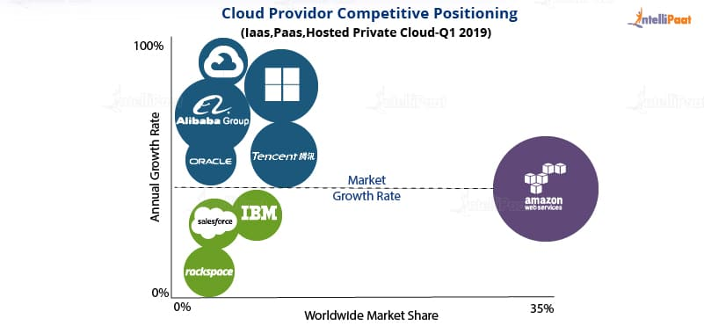

Even though both [Microsoft Azure](https://intellipaat.com/blog/what-is-microsoft-azure/) and GCP are lagging behind AWS, when it comes to market shares, they have shown tremendous growth rate. The following graph shows that, as of 2019, GCP has shown a growth rate of 83 percent while Microsoft Azure is at the second place with 75 percent of growth rate and AWS, at the third place, with 41 percent of growth rate.

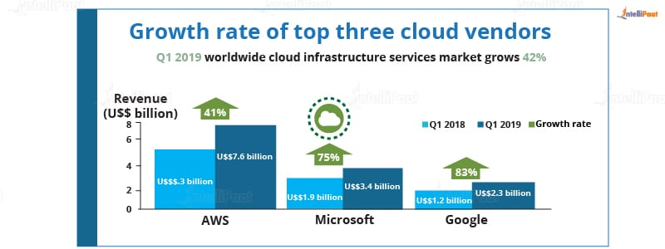

Database Services:

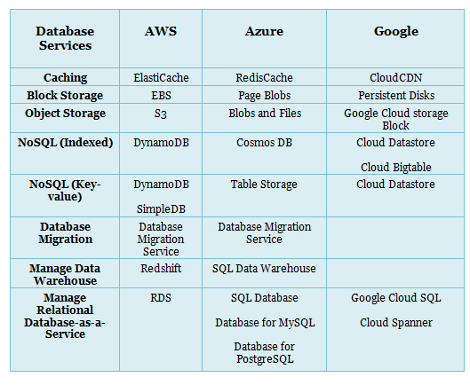

Networking Services:

